

🏫 Little Oaks Preschool

Funding and Fees Information
01564 783225 / littleoaksprechool@welearn365.com
Thank you for choosing Little Oaks Preschool for your child’s early years education. We are pleased to offer both funded and paid childcare options for children aged 2 and 3 years. The information below outlines our current session options, associated costs, and funding offers available for eligible families. All ages mentioned in this document refer to the child's age at the start of each term.
Session Options and Standard Fees
We offer the following sessions for children aged 2 and 3:
Session | Times | 3 Year Old’s | 2 Year Old’s
Morning | 8:30am – 1:00pm | £40.50 | £42.30
Full Day | 8:30am – 3:45pm | £65.25 | £68.15
Ad hoc | Sessions may be offered subject to availability and are charged at the standard fee rate. Parents are advised to contact the preschool directly to book.
Government Funded Hours
Funding is available for eligible families as follows:
Age | Funding available
3 Year Old’s (universal entitlement) | 15 hours childcare for all families in England.
3 Year Old’s (working parent entitlement) | 30 funded hours per week for eligible working families.
2 & 3 Year Old’s (working parent entitlement) | 15 funded hours per week for eligible working families from the day your child turns 2 (increasing to 30 funded hours from September 2025).
2 Year Old’s (2help) | 15 hours per week for eligible families who receive some additional forms of support.
Tax Free Childcare | We accept Tax Free Childcare – a government scheme that helps with childcare costs up to a maximum of £2000 for each eligible child per year.

Funded Session Fees
The below rates apply to families using government funding:
3 Year Old’s
Session | Funded Hours Used | Fee
Morning | 3 hours | £13.50
Full Day | 6 hours | £11.25
Full Day | 3 hours | £38.25
2 Year Old’s
Session | Funded Hours Used | Fee
Morning | 3 hours | £14.10
Full Day | 6 hours | £11.75
Full Day | 3 hours | £39.95
Funded hours are applied during the following periods:
- Morning Sessions: 3 hours of funding between 9:45am – 12:45pm
- Full Days: 6 hours of funding between 9:45am – 3:45pm
Additional Charges
To cover the cost of enhanced experiences and resources, the following daily fees apply:
- Morning session: £2.50 per day
- Full day session: £3.50 per day
These charges contribute towards snacks** and drinks, sun cream, cooking ingredients, celebration events, visitors, ICT sessions, library time, forest school, sports and more.
**Parents who choose not to pay the additional charge for snacks and related provisions are welcome to provide their own snacks from home. However, in such cases, the preschool guidelines on food suitability must be strictly followed to ensure the health and safety of all children. These requirements, including restrictions on certain foods and the need for appropriate preparation, are outlined in full within our terms and conditions. We kindly ask all parents to familiarize themselves with these guidelines prior to sending food into the setting.

Wrap Around Care (Optional)
Available for all preschool children:
Service | Time | 3 Year Old’s | 2 Year Old’s
Breakfast Club | 7:45am – 8:30am | £6.25 | £6.75
After School Club | 3:45pm – 6:00pm | £15.50 | £16.50

Meals
Children may bring a packed lunch from home or choose a hot school meal (ordered and paid via ParentPay).

Minimum Booking Requirements & Registration Fee
A £55 registration fee is required to secure your child’s place. This fee is offset against a minimum of two settling-in sessions. Minimum sessions are as follows:
- 3 Year Old’s: Minimum of 2 full days or 4 morning sessions per week
- 2 Year Old’s: Minimum of 1 full day or 2 morning sessions per week
How to Claim Your Funding
To claim your funded hours, please ensure:
1. You have completed a preschool starter pack and provided proof of your child’s age (birth certificate).
2. You have received your 15 or 30 hour eligibility code (if applicable).
3. You complete a Parental Declaration Form.
4. All necessary documentation is submitted before the start of term.
Funding | Application process
3 Year Old’s (15 hours universal entitlement) | No application needed. Preschool will manage the claim process for you. Children become eligible for funding the term after their third birthday.
3 Year Old’s (working parent entitlement) | You will need to apply online through the gov.uk website. If eligible, you will obtain an 11 digit eligibility code. Please provide the preschool with this code and ensure you reconfirm your eligibility every 3 months.
2 & 3 Year Old’s (working parent entitlement) | You will need to apply online through the gov.uk website. If eligible, you will obtain an 11 digit eligibility code. Please provide the preschool with this code and ensure you reconfirm your eligibility every 3 months.
2 Year Old’s (2help) | Families receiving some additional forms of government support, such as certain benefits or credits, may be eligible. Apply online through the gov.uk website.
EYPP | EYPP gives providers additional funding to support disadvantaged children accessing entitlement place. Preschool will manage the claim process for you.
DAF | A child will be eligible for DAF if the child is in receipt of Disability Living Allowance (DLA) and receiving early years funding entitlement. Apply online through the gov.uk website.
For more information on how to confirm funding eligibility or the process of applying for early years funding, please visit www.childcarechoices.gov.uk/ or www.warwickshire.gov.uk/childcarecosts. We are happy to help guide you through your funding application and calculate a personalised funding schedule based on your chosen sessions.
If you have any questions or would like to discuss your child’s place at Little Oaks Preschool, please do not hesitate to contact us.
Little Oaks Preschool littleoaksprechool@welearn365.com 01564 783225

Terms and Conditions / Childcare Contract

Booking and Fees:
To reserve a place at Little Oaks Preschool a completed registration form is required. Once your place has been confirmed a non-refundable booking and admissions fee of £55.00 which will be used towards a minimum of two settling in sessions.
Additional fees for sundries will be added to all invoices to cover all snacks, drinks, forest school, sun cream, cooking ingredients, cost of visitors and groups, events, celebrations, library and ICT sessions & sports. Parents must be aware that where the fee is not paid children may not be able to take part in various events and activities. Any parent not wishing to pay for these additional services can provide snacks and drinks from home that adhere to government guidance for all Early Years settings. Please use the following link for more details: www.gov.uk/government/publications/early-years-foundation-stage-nutrition
Fees are invoiced on a termly basis. Payment can be made in instalments but must be settled in full by the end of each term otherwise a late payment fee of 5% will be incurred. Payment can be made using childcare vouchers and via ParentPay. The Preschool is open term time only. If you have booked / reserved your child’s place in our Preschool and for whatever reasons your child does not attend, fees for those booked places must be paid for in full.
This contract secures a fixed place for the school year. Four weeks’ notice is required to cancel your child’s place at Little Oaks Preschool. If you require additional ad hoc extra days, over and above your contract, these can be booked subject to availability by contacting the Preschool directly. Little Oaks Preschool will give at least four weeks’ notice of any alteration to fees or our agreements with you. Four weeks’ notice is also required from parents for any change of days to the agreed pattern.

Additional Fees:
These charges contribute towards snacks** and drinks, sun cream, cooking ingredients, celebration events, visitors, ICT sessions, library time, forest school, sports and more.
**Parents who choose not to pay the additional charge for snacks and related provisions are welcome to provide their own snacks from home. However, in such cases, the preschool guidelines on food suitability must be strictly followed to ensure the health and safety of all children. These requirements, including restrictions on certain foods and the need for appropriate preparation, are outlined in full within our terms and conditions. We kindly ask all parents to familiarise themselves with these guidelines prior to sending food into the setting
Please tick below:
Option A:  Opt-in | I agree to pay the additional fees for the extra services provided by the school.
Option B:  Opt-out | I choose not to pay the additional fees. I agree to supply all snacks, drinks, sun cream etc for my child. I understand that my child will not participate in certain activities, such as Forest School. If I fail to provide these daily essentials, I will be charged the additional fees for those days.

Preschool Policies and Procedures:
Parents are requested to read and adhere to all relevant policies and procedures. These are available on the school website.

Children’s Information and Personal Records:
You are required to complete and sign a comprehensive admission form prior to your child starting the Preschool. This information will be kept on file and referred to when necessary. It is parent’s responsibility to update a child’s contact or medical information with Little Oaks Preschool. In line with current Safeguarding and Welfare requirements, you will be required to indicate which parents have Parental Responsibilities for the child. It is vital that the information we hold on file is current and correct.

Illness and Absence:
It is the responsibility of parents / carers to keep any child away from the Preschool if they are unwell.
Any child suffering from any illness, should be kept away from Preschool and not return until well enough or have completed their isolation as required following NHS advice. Should a child become ill whilst at Preschool, every effort will be made to contact the parents / carer and to keep the child comfortable. Other exclusions apply.
Fees for absences will not be reimbursed. If your child cannot attend due to unexpected closure then refunds will be considered upon request.

Termination of placements:
The Preschool reserves the right to terminate a place if payment terms and conditions are not adhered to. Termination of places will also be applied as a result of any inappropriate behaviour by parents, carers or children.

Collecting Children:
Little Oaks Preschool staff must be notified by yourselves if you plan for your child to be collected by anyone other than those detailed on your admission form as having responsibility, we must be informed of the person collecting as soon as possible and before the actual time of collection. The safety and wellbeing of the children in our care is of the utmost importance.

Opening and Closing times:
The opening time of 7.45am or 8.30am and closing time of 1pm, 3.45pm or 6.00pm must be adhered to in order to enable the correct child adult ratios can be maintained. Failure to comply will result in extra charges being made to you. Late collection fees will be added to the invoices at a charge of £5.00 for the first 15min and an additional £5 for any additional 15min thereafter.

Data protection legislation:
The school is registered with the Information Commissioner for holding and processing of personal data. The school has a duty to protect this information and to keep it up to date. The school is required to share some of the data with other agencies including Warwickshire County Council and the Department for Education. Please see our Privacy Notice for full details of how we use and share personal information.
Please note that you have the right to withdraw or amend your consent for the sharing of personal information at any time, although we will need to have certain personal information to fulfil our legal duties. You can notify us of a withdrawal of or any changes to your consent in writing by contacting littleoakspreschool@welearn365.com.
I agree to abide by the terms and conditions of the Little Oaks Preschool.
Parents / Carers Name:
Signed (e signature accepted):
Date:

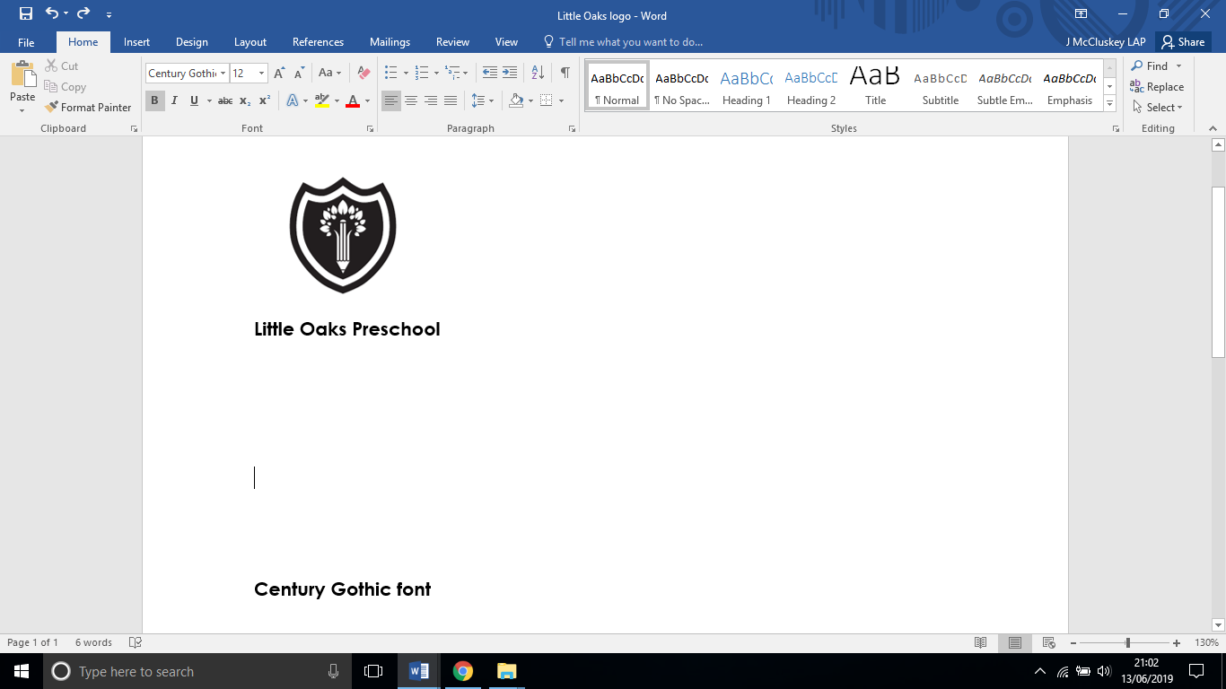
Admission Form
Forename: |  | Preferred name (if different):
Surname: |  | Middle name:
Gender: | Date of Birth:  ***Please attach copy of Birth Certificate***
Address: | Postcode:
Telephone no.
Email address to receive preschool messages etc.
In order of preference:  Emergency  Telephone Contact – 1 | Name: | Home: ______________________  Mobile:______________________  Work: ______________________
Relationship to child: |  | Parental responsibility? Y/N
Address if different to above:

Emergency  Telephone Contact – 2 | Name: | Home: ______________________  Mobile:______________________  Work: ______________________
Relationship to child: |  | Parental responsibility? Y/N
Address if different to above:

Emergency  Telephone Contact – 3 | Name: | Home: _____________________  Mobile:____________________  Work: _____________________
Relationship to child: |  | Parental responsibility? Y/N
Address if different to above:

Ethnicity: |  |  | EAL: Y/N
Lunch requirements: | - Hot Dinners  - Packed lunches (please circle choice)
Dietary requirements /
food allergies:
Previous setting or other Nursery that provides shared care:
Special educational needs:

Specific Password for identification:
_____________________________________________________________________
Please give details of any other person(s) who you authorise to collect your child in addition to those already named (must be over 16 years of age).
***Please advise staff on the day if a person listed below will be collecting your child***
Name:  Relationship to child:  Are there any set days that your child will be collected by this person? Please indicate:  Monday Tuesday Wednesday Thursday Friday | Tel No  Mobile
Name:  Relationship to child:  Are there any set days that your child will be collected by this person? Please indicate:  Monday Tuesday Wednesday Thursday Friday | Tel No  Mobile
Name:  Relationship to child:  Are there any set days that your child will be collected by this person? Please indicate:  Monday Tuesday Wednesday Thursday Friday | Tel No  Mobile

General consent:
I being the parent / carer give permission for my child to be taken directly to hospital or seen by the nearest doctor and be given any necessary treatment should an emergency arise. | Yes / No
I being the parent / carer give permission for my child to have a plaster applied if the need arises. | Yes / No
I being the parent / carer give permission for my child to have face paint applied during fun activities. | Yes / No
I being the parent / carer give permission for my child to use the sun cream provided by Little Oaks Preschool in the event I do not have my own sun cream available. | Yes / No
I being the parent / carer give permission for data sharing between other settings that my child attends or has attended in the past. | Yes / No
Names of professionals involved with child:
Name:  Agency: | Role:  Tel no:
Name:  Agency: | Role:  Tel no:
Name:  Agency: | Role:  Tel no:
Does your child have a health visitor? Yes / No
Name: Clinic:
Does your family have a social care worker? Yes / No
Name: Based at:
Data protection legislation: The school is registered with the Information Commissioner for holding and processing of personal data. The school has a duty to protect this information and to keep it up to date. The school is required to share some of the data with other agencies including Warwickshire County Council and the Department for Education. Please see our Privacy Notice for full details of how we use and share personal information.
Please note that you have the right to withdraw or amend your consent for the sharing of personal information at any time, although we will need to have certain personal information to fulfil our legal duties. You can notify us of a withdrawal of or any changes to your consent in writing by contacting littleoakspreschool@welearn365.com. Please indicate below the preschool sessions you would like to request for your child. Sessions apply to all ages.

Child’s name: |  |  | Date of birth:
 | Monday | Tuesday | Wednesday | Thursday | Friday
Breakfast club
7.45am - 8.30am
Morning session
8.30am - 1pm
Whole day
8.30am – 3.45pm
After school club
3.45pm – 6pm
Medical Record
Doctors Name:

Surgery Address:

Telephone Number:
 |  | Yes | No
Has your child had any of the following: | Asthma or Bronchitis
Has your child had any of the following: | Inhaler
Has your child had any of the following: | Heart Condition
Has your child had any of the following: | Fits, fainting or blackouts
Has your child had any of the following: | Severe headaches
Has your child had any of the following: | Diabetes
Has your child had any of the following: | Allergies to any known drugs or medication
Has your child had any of the following: | Any other allergies e.g. material, food, insect bites etc.
Has your child had any of the following: | Any specific dietary requirements
Has your child had any of the following: | Other illness or disability
Has your child had any of the following: | Any recent contact with contagious diseases & infections
Has your child had any of the following: | An existing Education Health Care Plan
Has your child had any of the following: | If the answer to any of these questions is yes, please state below:
Has your child received vaccination against Tetanus in the last five years? |  | Yes | No
Is your child receiving medical treatment of any kind from either your doctor or hospital? |  | Yes | No
Has your child been given specific medical advice to follow in emergencies? |  | Yes | No
If the answer to any of these questions is yes, please state below:

***It is important that you inform us of any changes to the form, so we can keep our records up to date***
Consent Form for the Recording and Use of Images

During the course of the school year, we may wish to take photographs or video recordings of children within Preschool or on trips, either for our own records, for use as part of our learning curriculum or for inclusion in our promotional material such as the school prospectus and our website.
The school may also invite an external photographer to the school each year to take official school photographs and may invite the media in to take photographs of pupils engaged in school activities or events for publication.
To comply with the General Data Protection Regulation, we need to ask your consent before the school record any images of your child. In view of this, please read the statements below complete the slip and return this form as soon as possible.
This table sets out the various reasons for taking and making use of images of your child and we should be grateful if you would indicate whether or not you give consent for use in these circumstances. By indicating ‘YES’, you are confirming that you consent to your child’s personal data being shared for those purposes and/or with the named third parties):
1 | For official school photographs, with images taken by DSP and available for purchase by parents, and held by the school for identification purposes with names attached. |  | YES / NO
2 | For use on internal school / preschool displays. |  | YES / NO
3 | For use as part of projects of work by students. |  | YES / NO
4 | For use on the school’s website or newsletter. |  | YES / NO
5 | Occasional sharing of images of your child with external media organisations, such as local papers and parish magazine or inviting such media organisations to take photographs of pupils (including your child) engaged in school activities or events for publication. |  | YES / NO
We also need your consent before your child’s name would be attached to any images accessible externally to the school (for example school website or printed media). Please indicate below whether you consent to this:
6 | Attaching your child’s name to images accessible externally to the school (e.g. social media, other websites or printed media) |  | YES / NO
You have the right to withdraw your consent at any time by giving the school written notice and completing a new consent form. Please notify us of consent withdrawal by email to: littleoakspreschool@welearn365.com.
Signature:
Name:
Relationship to child:
Date:

